EE4007 Optical Electronics (Semiconductor Optoelectronics)
P. J. Parbrook, p.parbrook@ucc.ie,

Course Aims
- Introduction to Semiconductor Materials
- Introduction to Quantum Mechanics
- Quantum Wells
- Semiconductor Light Emitting Devices
- Semiconductor Lasers
- Optoelectronic Semiconductor Device Manufacture
- Applications of Semiconductor Emitters (excluding Fibre Communications)

Fit with Professor Riza
- Basic Optics and Optical Effects
- Optical Communication Systems
- Applications of Fibre Systems
- Semiconductor Detectors and Applications

Introduction to Semiconductors (Revision)

Structural Properties
Semiconductors are usually covalently bonded materials. Virtually all semiconductors discussed in this course are a single crystal. In the crystals the atoms all line up perfectly, each with four nearest neighbours, arranged in a tetrahedron. This arrangement allows each of the four bonds to be symmetrically as far apart from each other as possible. It is difficult to draw this three dimensional structure in two dimensions, so often it is represented on paper as a "square" lattice.

It is also important to note that different directions in a crystal can have different properties.
In silicon, all the atoms are of course the same, and the crystal structure is called the “diamond” lattice. However, group IV semiconductors like Si and Ge do not emit light (although they can absorb it). We will discuss the reasons for this later.
Most light emitting semiconductors are made up of so-called III-V compounds. These include Gallium Arsenide, Indium Phosphide, Indium Antimonide and Gallium Nitride for example. In these materials the crystal structure is the same, but every alternate atom is group III or group V. This means that in GaAs each Ga atom is bonded to four As atoms and vice versa.

Electrical Properties

Key Concept: The Hole
When an electron leaves the bonding state there is a gap in the electron population in the bonding state. A neighbouring electron in the same bonding state can move into the gap causing the gap to move to where that neighbouring electron came from. This motion of the gap in the population can be likened to a positive particle moving in the opposite direction to the electrons. We can call this positively charged particle a hole.

Generation and Recombination
Free electrons and holes are continuously being created due to thermal energy in a semiconductor. These electrons and holes are free to travel around the material until they meet. When an electron meets a hole the electron will be able to fall back into the bonding state. The free electron and hole recombine, annihilating each other. In the same way that energy is absorbed to release an electron, so energy is emitted as the electron falls back into the bonding state.
In an equilibrium the generation rate and the recombination rate must be equal.
The recombination rate will be proportional to the number of free electrons and free holes in the material, and is written
R=Bnp (where B is a constant, n the density of electrons, and p the density of holes)

Doping
The number of thermally generated carriers depends on temperature and can be shown to be:
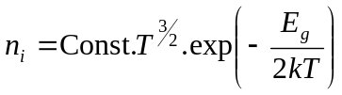
where T is in Kelvin and E_{g} is the energy required to free and electron from its bond.
At room temperature in most semiconductors the number density of thermally generated free carriers is very small, despite the exponential rise expected in n_{i}
We can add impurities into a semiconductor to change this. Consider the most common, elemental semiconductor, Si, which lies in group IV of the periodic table. If we add small amounts of a group V element, such as Arsenic then the four of the five outside electrons will bond up to neighbouring Si atoms, but the fifth will be only loosely attached to the As core. With a very small amount of thermal energy (less than that at room temperature) it can be released to become a free electron in the crystal.
Hence group V doping will donate free electrons to the material and increase the value of n. Arsenic is called a DONOR in this material and the material is called n-type.
By a similar argument we could instead add small amounts of a group III element, such as Boron. In this case there will be only three electrons to bond with the neighbouring Si atoms, so the fourth bond will have a hole in it. This hole is only weakly attached to the B atom and can again with a small amount of thermal energy it can be released to become a free hole in the crystal.
Hence group III doping can allow the impurities to accept neighbouring bonding electrons, releasing free holes. This increases the value of p. Boron is called an ACCEPTOR in this material and the material is called p-type.
For III-V Semiconductors we need to add different impurities. We can treat the crystal as in effect two interlinked lattices, called “sub-lattices”. We can dope the material p-type by either replacing an atom on the group III sub-lattice with a group II element (e.g. replacing a Ga atom with Zn), or an atom on the group V sub lattice with a group IV element (e.g. replacing As with C). Similarly we can make the material n-type by replacing a group III element with a group IV element (e.g Ga with Si) or a group V element with group VI (e.g. As with S).
It is important to note that chemistry does not allow one to dope n-type by somehow breaking the 1:1 ratio of group III and group V atoms. The two sub-lattices are essentially separate chemically in that we cannot force As to sit on a Ga site and vice-versa. A second point related to the chemistry of the crystal is that you can see from the above that group IV atoms can form either p-type or n-type dopants. This means they are so-called amphoteric dopants, at least in theory. In practice when the material is made the element will prefer to bond into one sub lattice rather than the other. Si is a well known, n-type dopant for GaAs and GaN. C makes a very good p-dopant for GaAs.
Finally it is important to recognise that not all possible dopant elements actually work. Sometimes the dopant is difficult to introduce into the material, and in other cases the “extra” electron or hole, remains bound to the impurity and cannot easily escape to provide either electron or hole conduction.

Conductivity.
How well a material can conduct electricity depends on three parameters:
- The density of free carriers in the material
- The charge on each free carrier.
- How mobile the carrier is (called mobility).
The charge is the standard charge on an electron, called e, which is positive instead of negative for a hole. The density of carriers is usually given by the doping.
In a material the free carriers can move around randomly due to thermal motion. This thermal motion is high and given by:
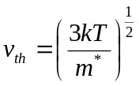
However thermal motion of carriers contains no net motion of charge.
The mobility depends on potentially how fast the electrons can travel in the direction one wishes to move them. This is called the drift velocity. When an Electric Field is applied the carriers are accelerated in the field. However they are decelerated when they collide with other “particles” in the solid.
The most common collision at room temperature is with vibrations of the crystal lattice. The vibrations are called phonons. The more often collisions occur the lower the average drift velocity of the free carrier will be and the lower the mobility, μ will be. At low temperatures, or in very highly doped material the charge carriers can be scattered by the impurities used to dope the material. The actual value of mobility depends on summing the inverse of the different contributions using Matthiessen’s rule:
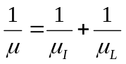
Where 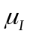is the mobility limited by scattering from impurities or defects and 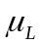 is the mobility limited by lattice vibrations (phonons). Mobility can be measured directly experimentally using a Hall Effect Measurement. It is important to remember that the mobility of an electron will not be the same as for a hole. To distinguish these we call them μ_{e} for electrons and μ_{h} for holes.
To calculate the value of the drift velocity we need to consider the balance between electrons gaining velocity by BEING ACCELERATED IN THE ELECTRIC FIELD, and losing velocity when THEY GET SCATTERED.
However this cannot be done considering a single particle, as the process of scattering is inherently random. If we consider a electron being regularly scattered every time interval we will get a result that is a factor of two too small!
To determine the drift velocity for the electrons in a semiconductor we must estimate the gain in momentum of the electron population as a whole due the application of the electric field, and then estimate the loss in momentum of the electron population due to a fraction of the electrons being scacttered in some time interval. In equilibrium these will balance and the a value of drift velocity can be calculated:
The gain in momentum for one electron is: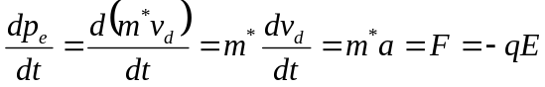
Thus for a population of electrons the total momentum gain is: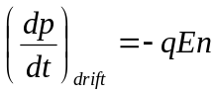
The loss in momentum can be estimated by assuming that some fraction of the electrons lose all their momentum per unit time. This will be the ration of the number of electrons in the population and the average time between scattering events, . Based on this the momentum loss for our population of electrons will be given by 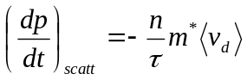
Where 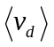 is the average drift velocity.
Equating the momentum gain and loss gives. 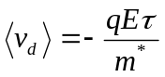
As 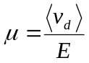 we have 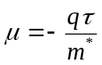
For a piece of n-type material the density of electrons is much greater than holes and we can write that the conductivity,σ is
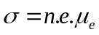
However if n and p are similar then 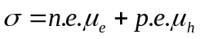

Drift and Diffusion
The net motion of charges can occur due to the application of an electric field (or voltage) across a material in which case the free carriers will DRIFT in the direction of the field.
The current density, J can be shown to be: 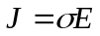where σ is as described above.
A net motion of carriers will also occur if there is a difference in the concentration of carriers in different regions of the material. In this case the free carriers will DIFFUSE towards the region with lower concentration, or down a concentration gradient.

The net movement, or flux, of carriers will be given by: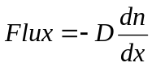 where D is the diffusion coefficient.
The current density, 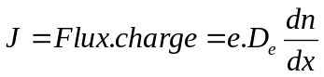.
The diffusion coefficient for electrons D_{e} can be shown to be given by 

